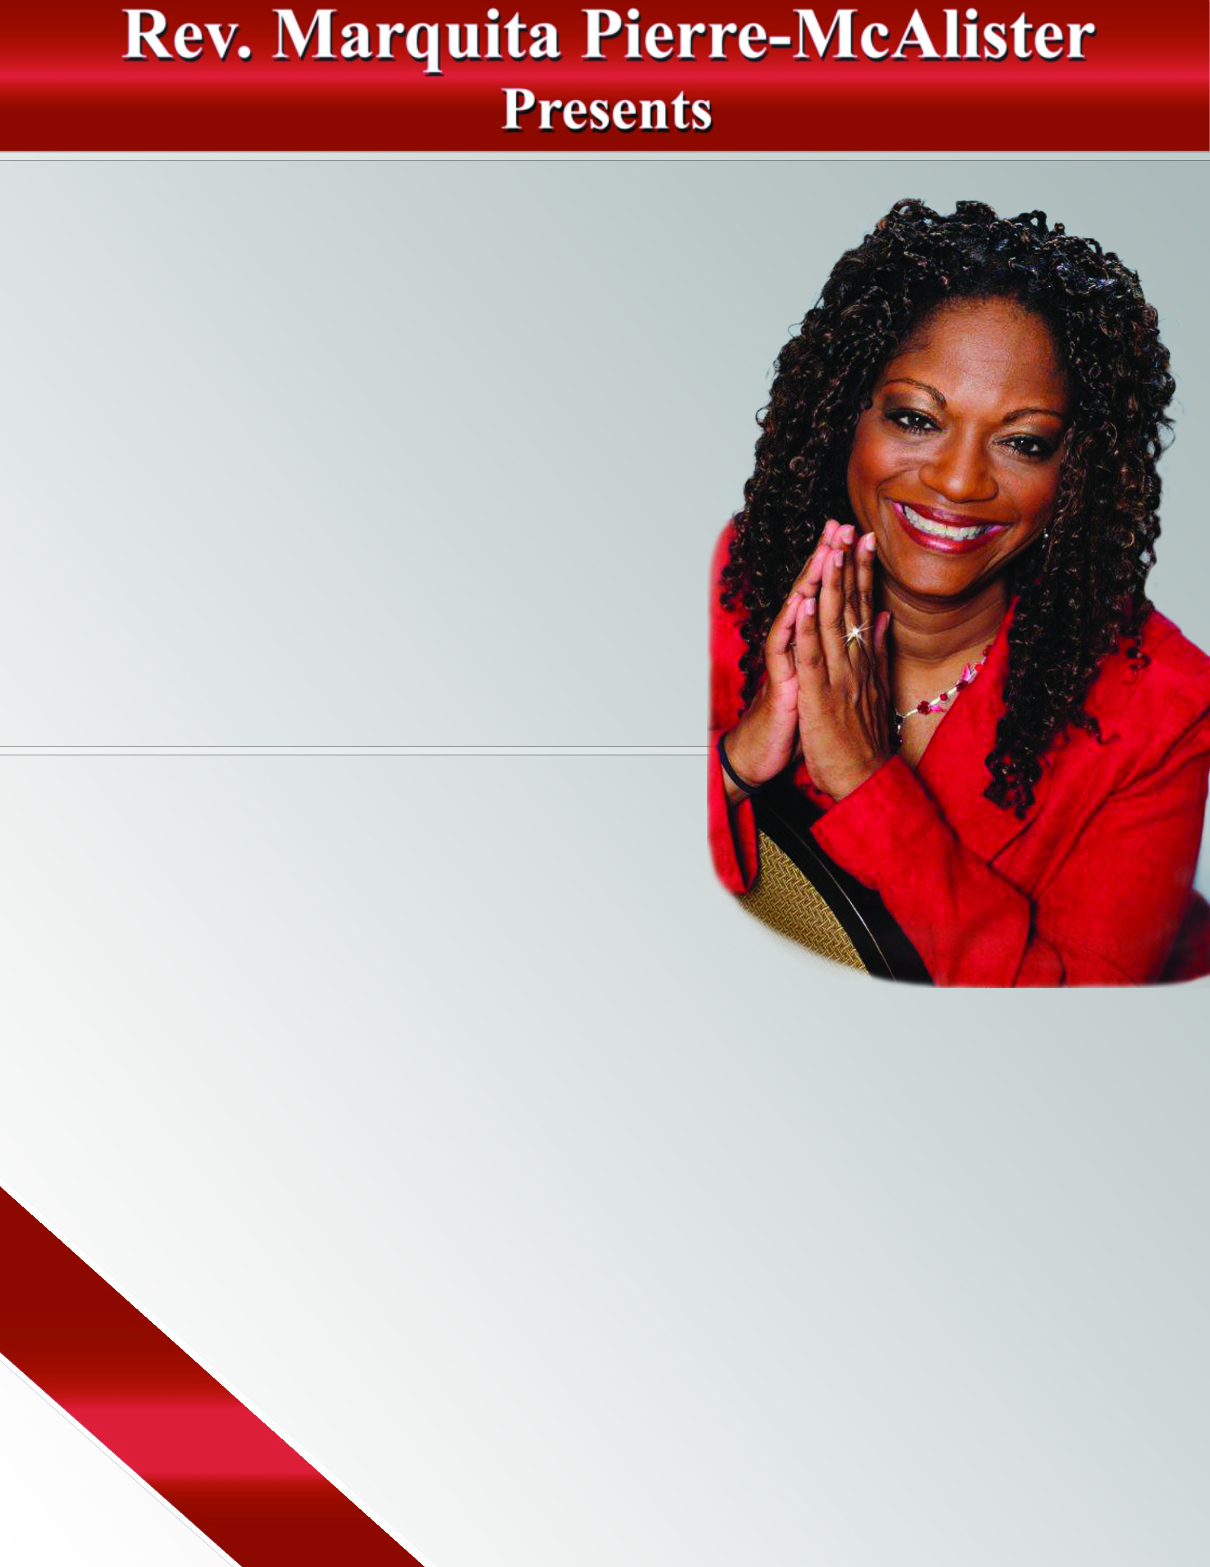

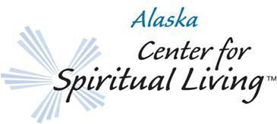

**DISCOVER, PRACTICE, LAUGH, SHARE,**

**EXPERIENCE, EXPAND YOUR MIND**

Followed by Empowerment

Workshop:

**“Revolution From**

**the Inside Out”**

**Tuesday, June 26th 6:30-8:30 p.m.**

Growth Investment: $40.00

* Practical Steps to Creating a New Better You
* Disrupt the Pattern of Subconscious
* Liberate Your Invisible Self
* **Unleash the Greatness Within!**

**discover, practice, laugh, share**, **experience**

929 E. 81stAve., Anchorage, AK 99518

(behind Fastenal on Old Seward Hwy near Dimond Blvd.)

[www.cslalaska.org](http://www.cslalaska.org/) 522-0940

**Find Us on Facebook**

* Identify more of your unlimited potential
* Discover whether your values are serving you while having fun
* Reclaim your power from what keeps your dreams just out of reach!

**“Discover Your Hidden Gem”**

**Mini-workshop: Sunday, June 24th**

**12:30-1:30 p.m. (conscious donation)**

**Sunday, June 24**